Jawad Tanana

MMAN1130
Final Assignment
z5320158 – Jawad Tanana

Table of Contents
Part A – Machining Theory Questions (20 marks) 2
1. What is near-dry and dry machining? What are the benefits of near-dry and dry machining? 2
2. Outline the instructions you would provide a machinist in order for them to produce a M16 x 2 screw holes in a 25mm thick plate of steel. You can assume that the steel is already clamped appropriately in the drill press machine and the machinist has access to all tools required. 2
3. One of your friends has created a drawing for a conveyor shaft (see Conveyor Shaft Drawing in Teams folder). This will form part of an assembly to autofill bean bags. However, they aren’t too sure if they have completed everything required for manufacture. He has asked you for your advice, and you, being the legend you are, are happy to assist. 3
a. You have noticed there is no tolerance for the diameter of the shaft where the bearings will sit. Provide an appropriate fit designation and justify your selection. 3
b. By modifying the providing drawing file, add the bilateral limits to the bearing seat diameter. Include an image of the updated drawing in your report. 3
4. Outline the necessary turning operations required to create the part in Figure 1. You can assume that an appropriate piece of stock has been secured into the lathe. HINT: A numbered list is much better than a long paragraph. 4
Part B – CAD Assembly and Process Planning Documents (40 marks) 6
Assembly Drawing: 7
Assembly Chart 8
Part C – HV Manufacture Study of CNC Machining Assessment Component 9
Compare three different HV manufacturing methods (one method must be CNC milling) summarising the pros and cons of each. 9
2. Perform a cost analysis on each method you investigated to select the most cost-effective method. A sample cost analysis table can be found in the Week 9 tutorial slides. Numbers should be based on real values with a source where possible. However, if this is not possible, an estimate with justification is acceptable. 11
Cost Analysis 12
For your selected cost-effective method, create a routing chart and work method sheet for each component. 14

Part A – Machining Theory Questions (20 marks)

1. What is near-dry and dry machining? What are the benefits of near-dry and dry machining?

Near dry machining is the use of coolant lubricant that is aerosolised and sprayed on the machine as it is making a cut. Whilst alternatively dry machining is the cutting of a material without the use of any lubrication or cooling. The reason that one may use coolant or lubrication is for the tool head to keep cool whilst cutting without to prolong the life of the tool head and to not ruin the material. Alternatively, though dry machining is used due to hazardous reactions such as magnesium and water will create a dangerous reaction. In addition, iron as it is being cut is much easier to deal with the dust that comes off rather than the sludge that it forms when mixed with a coolant. These are the benefits of both types of machining and the reason why one may choose one method over the other.

2. Outline the instructions you would provide a machinist in order for them to produce a M16 x 2 screw holes in a 25mm thick plate of steel. You can assume that the steel is already clamped appropriately in the drill press machine and the machinist has access to all tools required.
Disclaimer: Always take precautions when cutting and it is paramount that all safety rules are abided by.
Take note that we are cutting steel hence the Material removal rate rule must be observed.
Steel requires a Feed speed of 0.025 mm/rev and rotational speed ranging from 4300-6400 RPM.
As hole depth increases, speeds and feeds should be reduced.

- Attach a 5 mm centre drill to the drill press head, apply lubricant to the drill head and lower and begin to lower the head and drill approximately up to 1 mm in depth. This is in order to create a centre position to set up for the drilling and break the surface.
- Attach a 14 mm diameter drill piece to a drill press head and turn it on.
- Lower the machine head onto the point that was made by the centre drill and lower at 1.3 mm depths and raise the drill bit. Apply lubrication and lower, keep repeating this process until the desired depth has been achieved.
- Remove the drill head and attach a 16 mm tapping head and 2 mm pitch. Screw in the hand screw for the tapping process and begin hand twisting the tapping machine. ¼ clockwise twist and 2/4 anti-clockwise twist.
- If the hole is very deep remove the tapping mechanism and empty the chips and reapply lubricant. Then repeat step 4 until you have reached the bottom of the hole.

3. One of your friends has created a drawing for a conveyor shaft (see Conveyor Shaft Drawing in Teams folder). This will form part of an assembly to autofill bean bags. However, they aren’t too sure if they have completed everything required for manufacture. He has asked you for your advice, and you, being the legend you are, are happy to assist.

a. You have noticed there is no tolerance for the diameter of the shaft where the bearings will sit. Provide an appropriate fit designation and justify your selection.

I would apply an interference fit in order for the shaft to twist attach to the bearing and allow for the shaft to twist with the bearing hence the product to slide across and fill the bean bags.

b. By modifying the providing drawing file, add the bilateral limits to the bearing seat diameter. Include an image of the updated drawing in your report.

For reading purposes Tolerance = 0.0065 mm

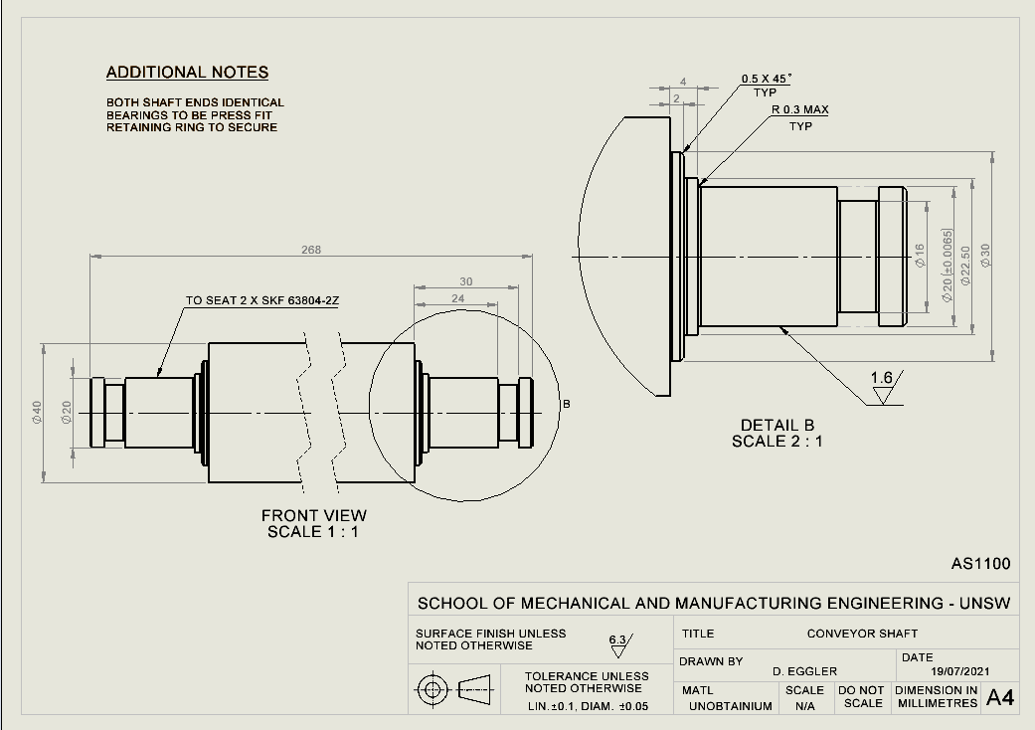

c. Explain why a clearance or transition fit would not be ideal for the proposed operation.

A clearance and tolerance fit would not allow the conveyor shaft to latch onto the hole bearing hence the shaft not twisting to allow the products to pass by.

4. Outline the necessary turning operations required to create the part in Figure 1. You can assume that an appropriate piece of stock has been secured into the lathe. HINT: A numbered list is much better than a long paragraph.

- We would narrow down the tool, making sure that we apply the facing tool at right angles to the stock. We will apply a rough turning operation to get the diameter of the largest diameter of the stock.
- Next, we will create a facing operation and shorten the stocks length to get the right height for the candle stick
- The next operation that we will apply will be a step turn (turning operation), this creates two surfaces with an abrupt change in diameter between them. As we go along the stock with this operation, we will change the diameter of the stock we will do a slight dip under the cup section to account for the thinning of that section then along the bottom widen out to account for the wider dish.
- After we will change to a grooving operation where we will apply it right under the cup of the candlestick to account for the narrow body.
- Next, we will apply a contour turning operation which will be applied to define those curves on the candlestick edge, passing over multiple times to create the desired contours stopping at the last contour before the widening of the stock. Starting from the top to the bottom before the diameter begins widening.
- We will start a taper turning operation to the bottom piece as the diameter begins to widen to account for the ramp like feature.
- Then we will complete a profiling operation to create the groove which surround the stem of the stock.
- After the dish widens out there is a reduction in the diameter, this is where we will apply a taper finish to reduce the diameter.
- We will then now begin a drilling operation where we will drill axially into the top of the candle stick in the centre.
- This will be followed by a boring operation which will expand the hole drilled to the diameter specified for the candle cup holder. Assuming the cup sits flat at the bottom of it.
- We will pass over the all the pieces with a finishing operation to smoothen out all the edges using a contour tool for the upper three quarters. Followed by a finishing taper operation for the increase in diameter section beneath the stem.
- Finally using a profiling operation again we will smoothen out the groove we created.

Part B – CAD Assembly and Process Planning Documents (40 marks)
Using the provided component drawings of a roller bracket, you must:

1. Create part files for each component in Solidworks (.sldprt).
2. Assemble the system in Solidworks (.sldasm)
3. Create an assembly chart and an assembly drawing (with bill of materials).

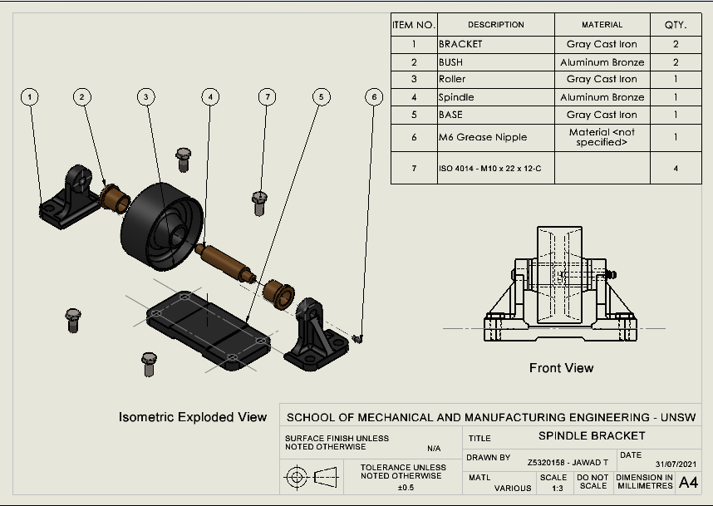
Assembly Drawing:

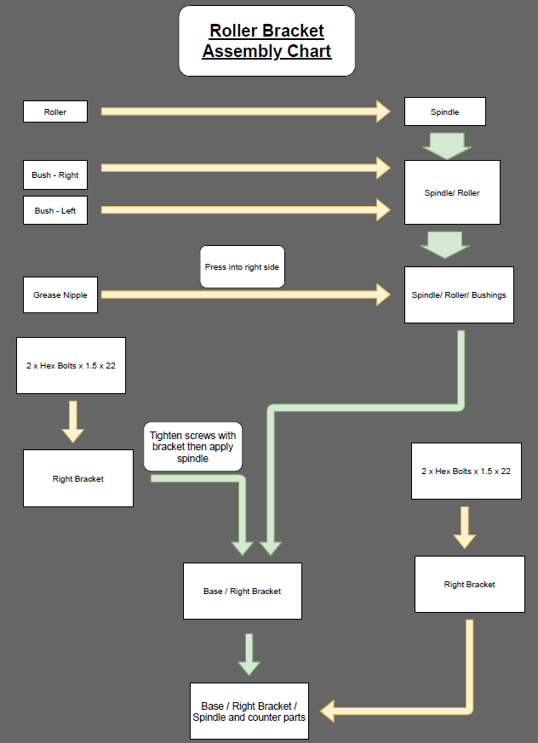
Assembly Chart

Part C – HV Manufacture Study of CNC Machining Assessment Component
With your newly acquired knowledge in high-volume (HV) design, you are now taking your wonderful primary and complementary parts from the CNC Machining Assessment to the masses. Your task is to create a HV process plan to manufacture 50,000 sets of the primary and complementary parts.
Note: 1 set consists of a primary AND complementary part. (50,000 Primary, 50,000 Complementary)

Compare three different HV manufacturing methods (one method must be CNC milling) summarising the pros and cons of each.

High volume is the production of large numbers of an identical product on an occasion. In order to manufacture these products, there needs to be a process. There consists of various processes to manufacture products on a large scale. The three that will be discussed are; sand casting, die casting and CNC milling.

Sand Casting:
The process of sandcasting has a typical low production rate, meaning that the number of parts created per hour is low. Sand casting involves various pieces such as a furnace, metal, and sand mould. It is wildly that have complex and irregular shapes, they can vary in size and weight being from a few milligrams to several thousand kilograms. Typical parts that are constructed using this technique for smaller objects are gears, pullers and crankshafts. Whilst for larger objects this method is used to create housings for larger equipment and heavy machinery and automobile parts (Custom Part 2019).
Sand casting is a 6-step process consisting of mould making, clamping, pouring, cooling, removal and trimming.
    - Mould making is the first step of the production process this consists of packing sand into the shape that you would like to construct. Each casting needs its own sand mould. Internal patterns which can not be moulded are made with separate cores (additional pieces that form internal holes and passages).
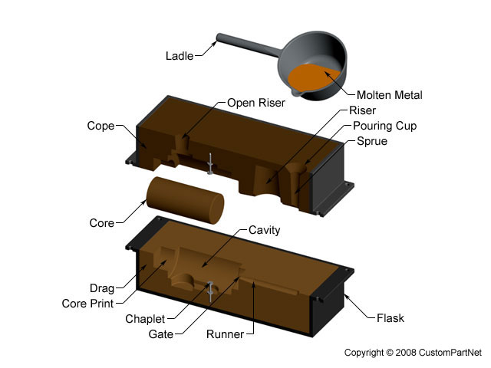
Figure 1: Mould Cast make (Custom Part 2019)

    - Clamping is the process of putting the mould halves together as seen in the above figure. Prior to clamping the moulds are lubricated in order to aid in the extraction of the piece after it has cooled down.
    - Once Molten metal has been created by keeping it at a high melting temperature in a furnace, it is poured into the casting filling up all the cavities using a ladle. Pouring time is kept short in order to avoid early cooling of one part over the parts being poured.
    - Once the metal has been poured the cooling process begins, it is estimated based on the wall thickness of the casting and the temperature of the metal. The solidification process of the manufacturing of the parts is where most of the defects occur during sandcasting.
    - Removal commences after the estimated time for solidification of the material occurs, the sand mould is simply cracked open, and the cast removed using vibrating techniques to rid the cast of sand.
    - Whilst the metal is being poured certain features must be added to the mould to accommodate pouring into the cast. These extra pieces must be trimmed from the casting manually via cutting or using a trimming press. The extra pieces are sometimes reconditioned and recycled to be used for future castings.

There lie many advantages such as the ability to produce large parts, forming of complex shapes, variety of material options, not an excessive number of tools and equipment, the scraps can be recycled and the ability to have a short lead time. Contrary to the advantages, the process also has disadvantages which consists of poor material strength, poor surface finishes and tolerances of the product, secondary machining often required, high labour costs and low production rate. (Custom Part 2019)

Die Casting:
Die casting is a manufacturing process which allows us to produce complex metal parts. This is achieved through the use of reusable moulds called dies. There consists of two typical die casting machines, a hot chamber machine and cold chamber, used for alloys with low melting temperatures and used for alloys with high melting temperatures respectively. As molten metal is injected into both machines, the metal cools down and solidifies, hence forming a cast.
The die casting method achieves its production through five steps; clamping, injection (injecting with molten metal), cooling, ejection (push the casting out) and trimming (excess parts that need to be sawed off). The advantages for such a process reside in its abilities to produce large parts, form complex shapes, very good surface finish and accuracy, high production rate, low labour cost and the scrap can be recycled. Although with all advantages come the disadvantages and this consists of the fact that it needs to be trimmed, the die life is very limited, long lead time and tools and equipment are costly.

CNC Milling:
CNC milling also known as computer numerical control is the programming of a computer to give precise movement to be carried by a machine to produce an object. Milling is the process of drilling and cutting a material hence the combination of these two words leads to the conclusion that CNC milling is simply computer accurate milling processes that would otherwise be done by a human (Theias 2019).
This manufacturing process comes with its advantages which consist of the fact that it can continuously be used as long as it has power and fresh new tool pits once they wear out. The machines are very consistent producing the same quality on each part and shape. The staffing, software, technology and managing of the tool can be completed by a handful of people meaning less labour costs. The machine is easily operated as well thus reducing the need of highly qualified people. The disadvantages that come from this process is the cost of CNC machines which are reducing due to their high demand. The size limitations of a CNC machine in relation to its cost is also a disadvantage that comes with it, as the size of the parts become much larger the bigger the CNC machine will need to be hence the cost will increase dramatically. (Ricardo and Barbosa 2019)

- Perform a cost analysis on each method you investigated to select the most cost-effective method. A sample cost analysis table can be found in the Week 9 tutorial slides. Numbers should be based on real values with a source where possible. However, if this is not possible, an estimate with justification is acceptable.

Direct Material - Aluminium Notes:
- Density of Aluminium = 2.7 g/cm³
- Volume = 50 x 50 x 15 = 37500 mm³
- Mass = 101.25 gram
- Units = 100,000
- Total mass = 10125 Kg
- Aluminium Cost = $3.51 AUD (finanzen.net GmbH 2019)

Depreciation:
Useful years = 17 years (ATO, n.d.) (average)
10% depreciation rate
Die tools = 4 years (ATO, n.d.) (average)
Salvage value of Sand Casting = $27,300 (10 years) calculated using ATO depreciation values
Salvage value of Die Casting = $ 10,443.62 (10 years) calculated using ATO depreciation values
Salvage value of Die Casting = $1,073.74 (10 years) calculated using ATO depreciation values

Direct Labour:
China Factory labour hire = $8.85/hour
CNC labour hire AUS = $30 / hour

Operating Cost:
CNC:
Electricity costs in Australia = 34.41 c /KWH
40 hour works week
CNC = 1 KWH
Electricity cost = $13.76 p.w

Product Capacity:
Hours:
CNC = 7.5 minutes per part (average)

Cost Analysis
Primary
 | Sand Casting | Die Casting | CNC Milling
Quantity required | 50,000 | 50,000 | 50,000
Machine Setup Costs (M.S.C) | $25,000 | $125,000
 | (Tutorial) | (Tutorial)
Operating Cost (Sand, Electricity, etc) | $20,000.00 | $25,000.00 | $2,150.00
Operating Cost (Sand, Electricity, etc) | (Tutorial) | (Tutorial)
Cost of Equipment (C.O.E) | $85,000 | $29,952 | $15,000
Cost of Equipment (C.O.E) | (ALIBABA 2021) | (Ali Baba Die 2021) | (ALI BABA CNC 2021)
Depreciation on equipment (D.O.C) | $5,770 | $1,951 | $893
(10-year life) (per year) | $5,770 | $1,951 | $893
Production Capacity (PC) | 20 | 300 | 8
Production Capacity (PC) | /hr/shift | /hr/shift | /hr/shift
Production Capacity (PC) | 4 | 2 | 1
Production Capacity (PC) | People | Person | Person
Time Taken (Quanity of units / per hour * 40) | 62.5 | 4.166666667 | 156.25
Direct Labour (DL) | Total hours for run * wages | Total hours for run * wages | Total hours for run * wages
Direct Labour (DL) | $88,500 | $2,950 | $187,500
Direct Material (DM) | $14,215.50 | $14,215.50 | $14,215.50
Total Overheads | $50,770 | $151,951 | $3,043
TOTAL COST | $153,486 | $169,116 | $204,758
Price per Unit | $3.07 | $3.38 | $4.10

Complementary
 | Sand Casting | Die Casting | CNC Milling
Quantity required | 50,000 | 50,000 | 50,000
Machine Setup Costs (M.S.C) | $25,000 | $125,000
 | (Tutorial) | (Tutorial)
Operating Cost (Sand, Electricity, etc) | $20,000.00 | $25,000.00 | $2,150.00
Operating Cost (Sand, Electricity, etc) | (Tutorial) | (Tutorial)
Cost of Equipment (C.O.E) | $85,000 | $29,952 | $15,000
Cost of Equipment (C.O.E) | (ALIBABA 2021) | (Ali Baba Die 2021) | (ALI BABA CNC 2021)
Depreciation on equipment (D.O.C) | $5,770 | $1,951 | $893
(10-year life) (per year) | $5,770 | $1,951 | $893
Production Capacity (PC) | 20 | 300 | 8
Production Capacity (PC) | /hr/shift | /hr/shift | /hr/shift
Production Capacity (PC) | 4 | 2 | 1
Production Capacity (PC) | People | Person | Person
Time Taken (Quanity of units / per hour * 40) | 62.5 | 4.166666667 | 156.25
Direct Labour (DL) | Total hours for run * wages | Total hours for run * wages | Total hours for run * wages
Direct Labour (DL) | $88,500 | $2,950 | $187,500
Direct Material (DM) | $14,215.50 | $14,215.50 | $14,215.50
Total Overheads | $50,770 | $151,951 | $3,043
TOTAL COST | $153,486 | $169,116 | $204,758
Price per Unit | $3.07 | $3.38 | $4.10

Total Overheads = Machine Setup + Depreciation + Operating Costs
Total Cost = DL + DM + Total Over heads

Assume 40 hr work week, 48 weeks per year, Assume 1 machine

For your selected cost-effective method, create a routing chart and work method sheet for each component.

Work Method Sheet

Operation | Cold Chamber Die Casting
Part Name | Primary and Complementary Component
Quantity | 100,000
Operation Number | Operation description | Machine and Tools | Risk Assessment
1 | Mould is placed in die casting machine | Die Cast Machine | M
2 | Clamp the half dies together | Die Cast Machine | L
3 | Apply the molten metal to create the mould | Die Cast Machine | M
4 | Cooling time | Die Cast Machine | L
5 | Eject the mould | Die Cast Machine | M
6 | Prepare the half dies | Cleaning and Lubcricating | L
7 | Clamp the half dies together | Die Cast Machine | L
8 | Apply the molten metal to the machine at high pressure | Furnace and ladle | H
9 | Maintain pressure until the metal becomes solid | Die Cast Machine | L
10 | Cooling time | Die Cast Machine | L
11 | Open die | Die Cast Machine | L
12 | Eject part | Die Cast Machine | L
13 | Trim excess metal - retreated before being reused | Band saw | M
14 | Prepare the half dies to repeat | Cleaning and Lubcricating | L
15 | The holes and surfaces is cleaned | Shotblasting | L
16 | Sweeping pass is applied to improve surface finish | Vibration Deburring | L
 |  | Total Time | 20 seconds

Routing Chart
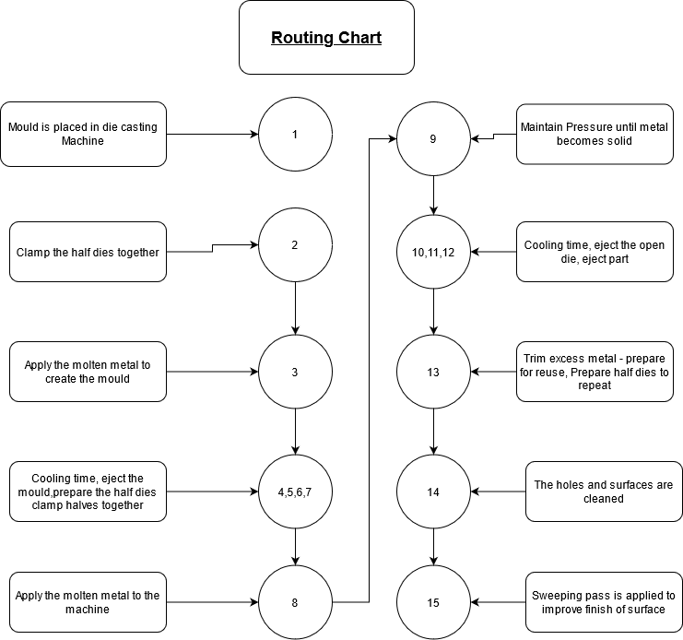

Bibliography
ALI BABA CNC. 2021. “Manufacturer Supply Cutting Carving Cnc Milling Machines 1325 Wood Engraving Machine - Buy Cnc Milling Machine,Engraving Machinery,Wood Engraving Machine Product on Alibaba.com.” Www.alibaba.com. August 1, 2021. https://www.alibaba.com/product-detail/Cnc-Milling-Machines-Machine-Cnc-Manufacturer_1600233762737.html?spm=a2700.galleryofferlist.normal_offer.d_title.4f0f5c49RWGeNm&s=p.
Ali Baba Die. 2021. “Dl-450/Dl-550 Brass Zinc Gravity Die Casting Machine,Metal Casting Machine Brass Aluminum Alloy Casting Machine - Buy Brass Zinc Aluminum Casting Machine,Metal Casting Machine Brass,Casting Machine Brass Alloy Die Casting Machine Product on Alibaba.com.” Www.alibaba.com. August 1, 2021. https://www.alibaba.com/product-detail/Die-Casting-Machine-Machinery-Machine-DL_62355833539.html?spm=a2700.galleryofferlist.topad_classic.d_title.faaa1044uWVbfW.
ALIBABA. 2021. “Flaskless Automatic Molding Machine,Steel Casting Sand Moulding Auto Parts Brake Pads Making Machine - Buy Casting Moulding Machine for Components Suppliers,Steel Casting Sand Moulding,Auto Parts Brake Pads Making Machine Product on Alibaba.com.” Www.alibaba.com. August 1, 2021. https://www.alibaba.com/product-detail/Machine-Casting-Sand-Flaskless-Automatic-Molding_60821142190.html?spm=a2700.7724857.normal_offer.d_title.61701a09QgTGLS&s=p.
ATO. n.d. “Depreciation Rates • Casting.” Www.depreciationrates.net.au. https://www.depreciationrates.net.au/casting.
Custom Part. 2019a. “Die Casting Process, Defects, Design.” Custompartnet.com. 2019. https://www.custompartnet.com/wu/die-casting.
———. 2019b. “Sand Casting Process, Defects, Design.” Custompartnet.com. 2019. https://www.custompartnet.com/wu/SandCasting
. Sand Casting
.
finanzen.net GmbH. 2019. “Aluminium PRICE Today | Aluminium Spot Price Chart | Live Price of Aluminium per Ounce | Markets Insider.” Markets.businessinsider.com. 2019. https://markets.businessinsider.com/commodities/aluminum-price
. Aluminium Cost
.
Ricardo, and Barbosa. 2019. “The Pros and Cons of CNC Machining - Ricardo & Barbosa.” Ricardo & Barbosa, January 24, 2019. https://www.ricardo-barbosa.com/the-pros-and-cons-of-cnc-machining/.
Theias, Mafalda. 2019. “What Is CNC Milling? – Simply Explained.” All3DP. All3DP. January 11, 2019. https://all3dp.com/2/what-is-cnc-milling-simply-explained/.
‌

